Date: Friday, 25 February 2022

Item: Event Management Plan

Event name: 2022 Paddle Australia Canoe Ocean Racing Championships

Tags: PACORC

Contact details: Scott Sharples, Executive Officer
Mobile: 0414 960 728, Email: eo.qld@paddle.org.au

Eden Williamson, Events and Communications Manager
Mobile: 0408 901 900, Email: qld@paddle.org.au

Venue details: Kirra Beach and The Spit

Event times: Saturday, 22nd January 2022

Event programme:

Wednesday, 19th January
1159 PACORC Registration closes

Thursday, 20th January
1030 PACORC Site inspections

1600 PACORC briefing posted and sent to all competitors

1630 PACORC entries listed online

Saturday, 22nd January
0630 Course Start and Finish Event Crews arrive

0730 Competitor Check in Opens at Course Start

0830 Water Safety put in Start, Turn 1 and Turn 2 cans (CoGC)

0900 Competitor Check in Closes

0930 Water safety in position for PACORC22 Race 1 Start

1000 PACORC Wave 1 Start – SUPs

1030 PACORC Wave 2 Start – Outriggers (OC) 1, 2, 3 and 6

1100 PACORC Wave 3 Start – Ocean Skis and Spec Skis

1300 onwards PACORC Waves Finish Course

1530 PACORC Presentations following Waves 1 + 2 (TBC)

1600 PACORC Presentations following Wave 3 (TBC)

1630 Event Crew clean up and leave site (TBC)

1800 PACORC Presentation Dinner (TBC)

Event Concept

In 2022 Paddle Australia will launch its inaugural Ocean Racing Championships (PACORC) on the Gold Coast.

Ocean Racing consists of long-distance surf ski, sea kayak and sea touring races. A surf ski is the fastest boat over long distances on ocean swells, with the only flatwater boat able to go faster being an Olympic-standard canoe sprint boat. The challenges canoe ocean racing can face include large waves driven by the wind, hurricane generated ground swells and paddling in wind speeds of more than 20 knots.

Surf skis originated in Australia in the 1900s when two brothers, Harry and Jack McLaren, used them around their family’s oyster beds on Lake Innes in New South Wales. They would also use their custom-made boats to surf the beaches at nearby Port Macquarie. The speed and versatility of the boats made them ideal for lifesaving, and in 1946 surf ski became a part of the lifesaving competition programme.

The 2022 PACORC will bring the ocean racing community from across Australia and beyond to the beautiful beaches of the Gold Coast and compete on a range of craft including Stand up paddle boards, Outrigger Canoes, Ocean Skis and Spec Skis for the honour of being crowned an inaugural Paddle Australia Canoe Ocean Racing Champion.

The top five (5) Junior, U23 and Senior Surf Ski athletes of the PACORC will also qualify for selection to represent Australia at the ICF Ocean Racing World Championships to be held in TBC from the TBC 2022.

Event Objectives

Paddle Queensland will deliver the below activities on the Gold Coast in January 2022:
- The Paddle Australia Canoe Ocean Racing Championships – a 27 km paddle starting at the Kirra Beach Surf Life Saving Club travelling north along the coast towards the finish line at The Spit south of the sand pumping jetty,
- Engage with and advise the Australian and Oceanic Ocean Racing communities that the PACORC is an ICF Ocean Racing World Championships 2022 qualifier
- Generate positive economic impact for the City of Gold Coast economy.
Significant Stakeholders

- Paddle Queensland
- Paddle Australia
- Paddle Australia Ocean Racing Technical Committee
- Kirra Beach Surf Life Saving Club

Stakeholders Roles

- Paddle Queensland
- Deliver the 2022 Paddle Australia Canoe Ocean Racing Championships
- Develop partnerships with the Ocean Racing Community
- Develop partnerships with the City of Gold Coast and Tourism Queensland
- Paddle Australia
- Assist Paddle Queensland in working with various council departments
- Assist Paddle Queensland finalise applicable permits
- Assist Paddle Queensland in marketing the PACORC across all media platforms and provide access to BTB marketing collateral
- Paddle Australia Ocean Racing Technical Committee
- Assist Paddle Queensland through providing technical support
- Assist Paddle Queensland in marketing the PACORC across all media platforms and provide

- Kirra Beach Surf Life Saving Club
- Assist Paddle Queensland through providing on and off water support
- Assist Paddle Queensland through providing access of their facilities

Stakeholder Communication

All communication regarding PACORC is to be directly channelled through Paddle Queensland.

All communication between stakeholders is to be recorded and if verbal communication is undertaken, an overview is to be emailed between stakeholders to ensure clarity.

Milestones

November 3rd Submit PACORC event management plan

4th Finalise resources, roles and responsibilities

5th Finalise budget

8th Confirm host agreement

9th Start discussions with City of Gold Coast and Tourism Queensland

10th Start resources recruitment

12th Finalise initial program

Lodge City of Gold Coast and Maritime aquatic event permits
18th Launch PACORC

Commence Marcom plan

29th Conclude resources recruitment

December 6th Appoint resources

Provide rules and manuals to resources with training schedule

13th Review partnerships and prizes

Resources training session # 1

20th Provide rules and manuals to resources with training schedule

25th Christmas Day

26th Boxing Day

27th Christmas Day (observed) holiday

28th Boxing Day (observed) holiday

31st Early Bird registrations close

January 1st New Year’s Day

3rd New Year’s Day (observed) holiday

5th Resources training session # 2

10th Confirm seaworthiness of all vessels

12th Resources training session # 3

16th Standard registrations close

19th PACORC entries close

Resources recap and brief

20th PACORC site inspections

22nd PACORC Race Day

February 18th Submit Post PACORC Report including Profit & Loss Statement

Marketing and Communications (MARCOM) Plan

Collateral will be supplied by PACORC Significant Stakeholders and distributed across all available platforms.
Launch: Thursday, 15th November at 1100
- Profile location
- How to get there
- Accommodation
- How to register
- Profile 2022 ICF World Championships qualification event

Engage: Tuesday, Thursday Saturday from 23rd Nov to 4th Dec
- Profile early bird rate
- Profile divisions
- Profile craft
- Profile location
- How to get there
- Accommodation
- How to register
- Profile 2022 ICF World Championships qualification event

Attract: Monday, Wednesday, Friday, Sunday from 6th to 31st Dec
- Profile early bird rate closes end of the month
- Profile prizes
- Profile location
- How to get there
- Accommodation
- How to register
- Profile 2022 ICF World Championships qualification event

Action: Tuesday, Thursday Saturday from 4th to 15th Jan 2022
- Profile standard rate closes 16th Jan
- Profile divisions
- Profile craft
- Profile prizes
- Profile location
- How to get there
- Accommodation
- How to register
- Profile 2022 ICF World Championships qualification event

Closing: Monday 17th to Wednesday 19th Jan 2022
- Registration closes 19th Jan
- Profile divisions
- Profile craft
- Profile prizes
- Profile location
- How to get there
- Accommodation
- How to register
- Profile 2022 ICF World Championships qualification event

Awareness: Thursday 20th and Friday 21st Jan 2022
- Profile registrations
- Profile divisions
- Profile craft
- Profile prizes
- Profile elite paddlers
- Profile location
- Profile schedule

Race Day: Saturday 22nd Jan 2022
- Profile prizes
- Profile elite paddlers
- Profile location
- Profile schedule
- Profile 2022 ICF World Championships qualification event

Results: Sunday 23rd Jan 2022
- Profile winners
- Profile results
- Profile 2022 ICF World Championships Team Selection qualifiers
- Profile and Thank Resources

Venue Issues

The start and finish areas will be sufficient to support the resources required to run the PACORC with current carpark and on street parking.

Exclusive PACORC areas at both the start and finish areas will be requested through council.

Course Issues

Depending on the prevailing conditions the course will run from The Spit to Kirra Beach.

Permits, Licenses and Insurances

The required PACORC event application for operation will be completed and submitted with the following items:
- Event Management Plan including Site Plan
- Risk Management Plan
- Public Liability Insurance noting relevant interested parties

Accreditation

Key resources and volunteers will be registered with Paddle Australia as either an Official or Volunteer which all are referred to as ‘Deliverers’.
These Deliverers:
- Work within the Paddle Australia Safety Guidelines
- Hold a Working with Children Check Blue Card
- Hold a current First Aid Certificate and/or CPR Certificate

Each activity has a detailed risk management plan. All Deliverers carry first aid and communication equipment. Part of their training includes monitoring situations including weather, environment impacts, other users and participants.

Safety is our highest priority!

Risk Management Plan

Please refer to the document titled 2022 PACORC Risk Management Plan.

Traffic Management Plan

The setup and running of PACORC will not affect the road network and road users. Parking for equipment trailers has been identified and will be requested to be coordinated off through council and the Kirra Beach Surf Life Saving Club

Due to the nature of paddle sports, it is very common for participants to park away from the event location and paddle to the event on their craft.

Public Access

Venue:
- Access to the PACORC will be available from the street, beach and sea.
- Signage will be placed along Musgrave Street, Marine Parade and around the
Kirra Beach Surf Club. Further signage will also be added near walkways and beach fronts to encourage community engagement.
- Signage will be placed along Seaworld Drive and around the Seaway Kiosk. Further signage will also be added near walkways and beach fronts to encourage community engagement.

Overcrowding:
- In line with all COVID-19 Restrictions the participation areas will be monitored by the COVID Marshall to ensure participants and spectators are abiding by the current social distance requirements

Accessibility:
- A drop off and pick up area will be marked to allow patrons with a disability to access the venue.

Staffing

Paddle Queensland:
Scott Sharples, Executive Officer
Mobile: 0414 960 728, Email: eo.qld@paddle.org.au

Eden Williamson, Events and Communications Manager
Mobile: 0408 901 900, Email: qld@paddle.org.au

Volunteers

Will be arranged by Paddle Queensland and include members from Southeast Queensland member clubs, Surf Life Saving Queensland clubs and Gold Coast Volunteers.

Food and Beverage

Food and/or beverages will be provided to all staff and volunteers. Participants will be encouraged to purchase food and/or beverages from the Kirra Beach Surf Life Saving Club and local establishments.

Waste Management

Paddle Queensland will be managing the PACORC waste requirements through the City of the Gold Coast.

Inclement Weather Aquatic Safety Plan
Should there be strong winds (over 30 knots) or rough seas (over 2 m swells) PACORC will be postponed to later in the day or cancelled one day at a time.

Forecast, Tides, Sun, Swell
Saturday, 22nd January:
Air: 31ºC Max
Wind: ESE 19 km/h with 30 km/h gusts
Sunrise: 0540 Sunset: 1851
Tide: Low 0420, 0.24 m High 1104, 1.58 m
Swell: 1.2 to 1.5 m

Sunday, 23rd January:
Air: 32ºC Max
Wind: ENE 13km/h with 22 km/h gusts
Sunrise: 0540 Sunset: 1851
Tides: Low 0505, 0.30 m High 1142, 1.51
Swell: 1.2 to 1.5 m

Site Plans

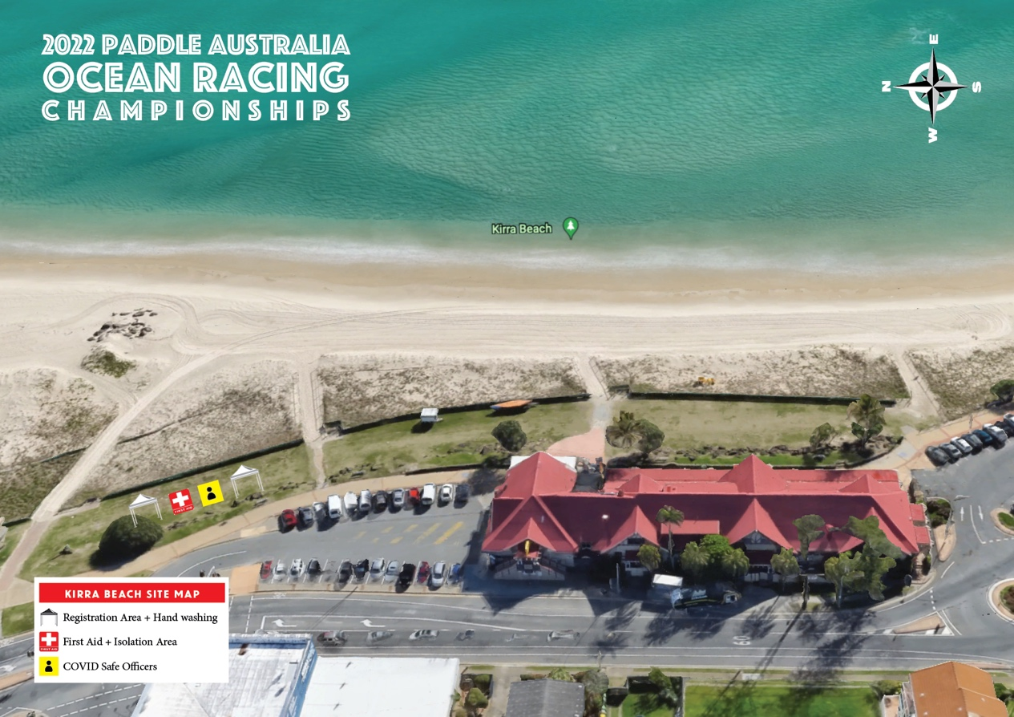
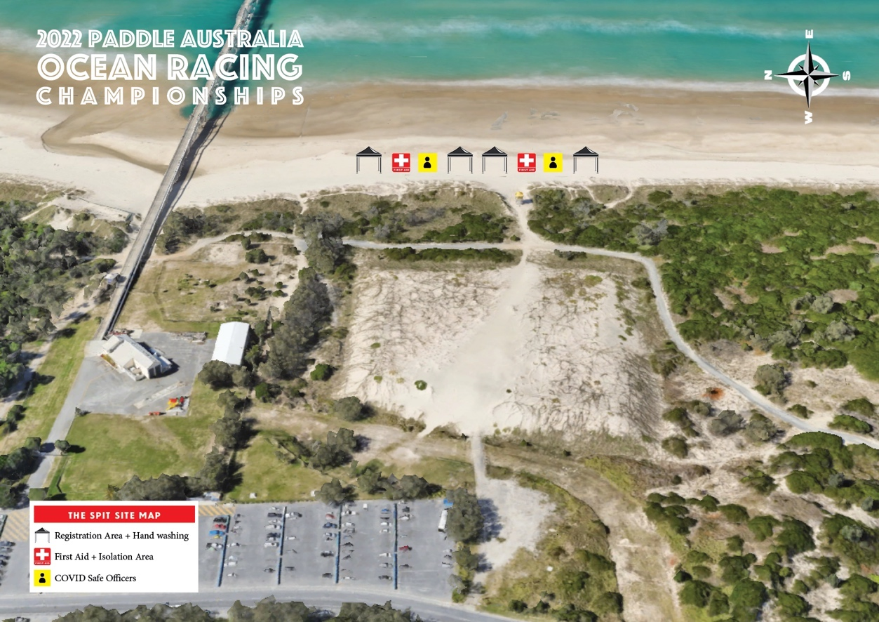

Course Map
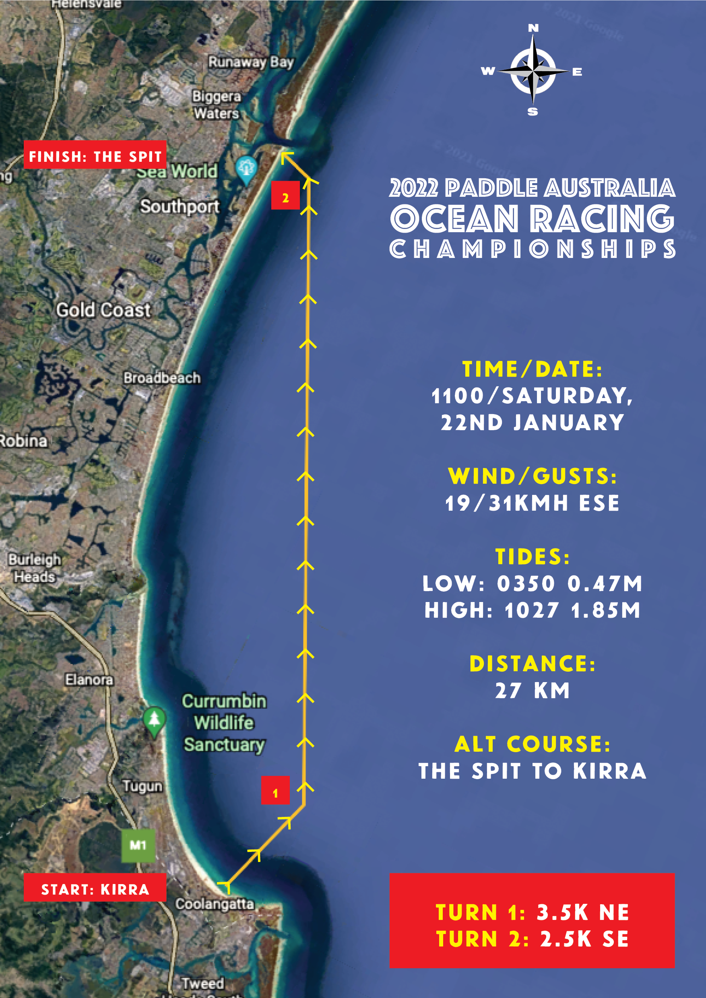

Beach Management Plan

The beach management plan will be setup as per the images below:
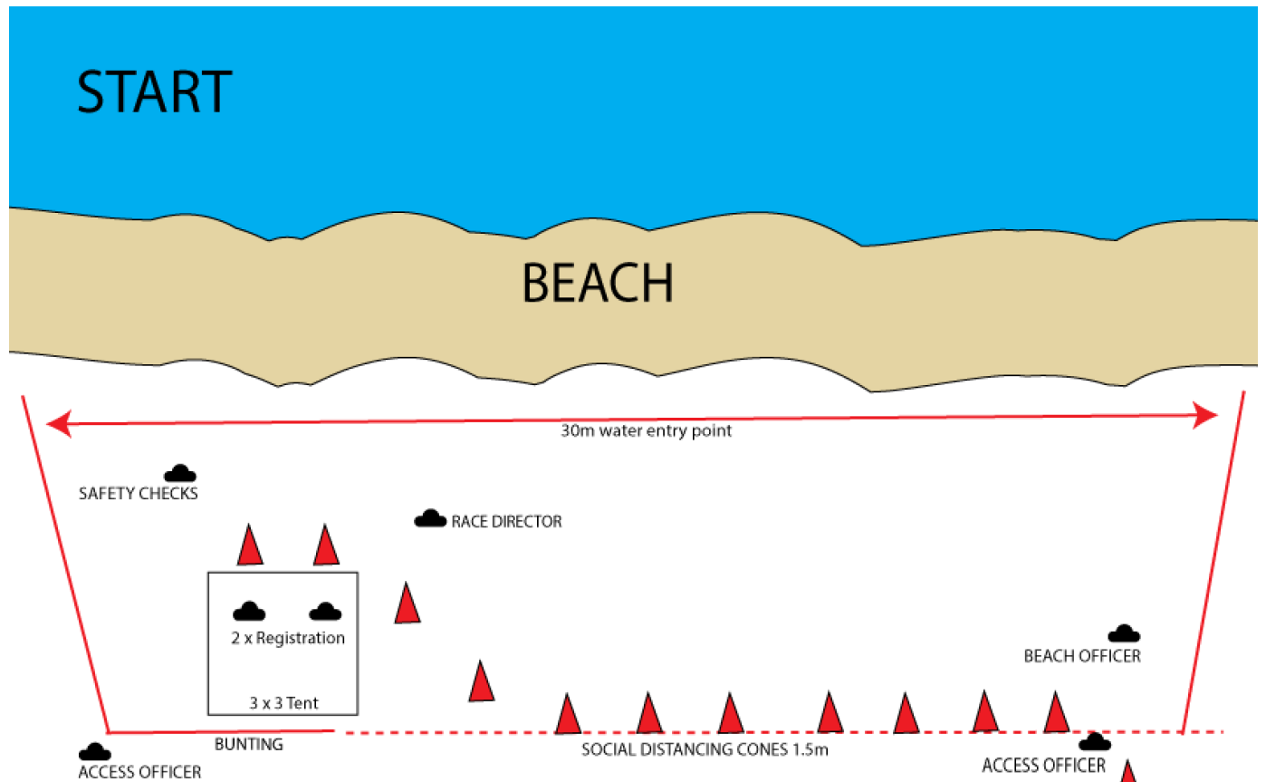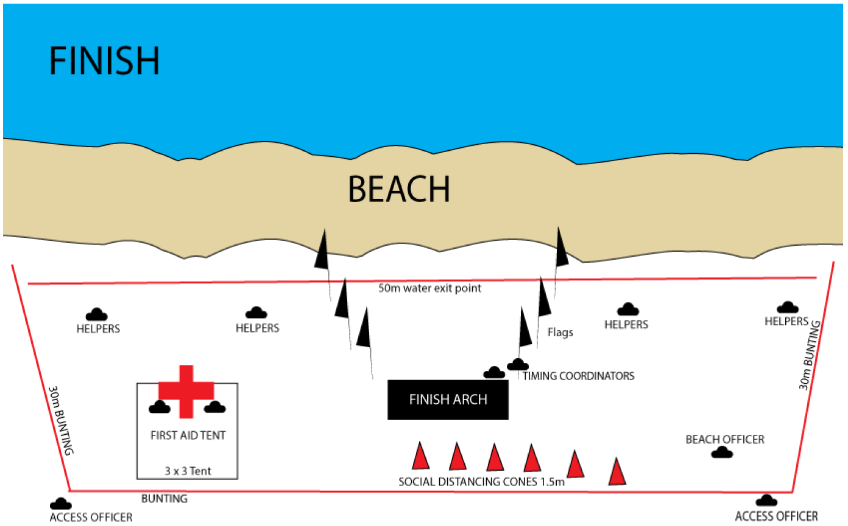

Competitor Briefing
Please refer to the document titled 2022 PACORC Aquatic Event Program.
Operating Procedure

Pre-Event
- Competitor paddle skill competency established through entry procedure.
- A maximum ratio of 50:1 Participant / Safety Boats will provide water safety
- Competitors will be registered at the start line and recorded as starting the event.
During event
- Vessel 1 will follow lead paddlers
- Vessel 2 will follow middle group of paddlers
- Vessel 3 will follow last paddler and “sweep” course
- Vessel 4 will operate between Vessels 1 and 2
- Vessel 5 will operate between Vessels 2 and 3
Course Marshall Details
- Vessel 1: Paddle Queensland
- Vessel 2: Paddle Queensland
- Vessel 3: Paddle Queensland
- Vessel 4: Paddle Queensland
- Vessel 5: Paddle Queensland

Course Marshall and Operator Fit for Duty Checklist
In line with, Marine Order (MO) 28 (Operations standards and procedures) each operator will not exceed the below minimum hours of rest required:
- 10 hours in any 24-hour period and 77 hours in any 7-day period; where
- the minimum hours of rest may be divided into no more than two periods, of which one must be at least 6 hours, and the interval between consecutive periods of rest must not exceed 14 hours.
Day prior to event
- Check bungs are screwed in firmly
- Check and fill fuel
- Check oil levels
- Check tires pressures
- Check motors and raise for towing
- Check all course buoys are aboard
- Check all safety equipment are aboard

Pre-Race
- Hook vessels to vehicles
- Head to entry and put vessels in the water
- Check communication between all vessels
- Setout course buoys
- Revisit Emergency Medical Communication Plan
- Revisit Emergency Medical Evacuation Plan
- Revisit vessels role
- Check communication between all prior to race start
Post-Race
- Collect course buoys and return to entry point
- Retrieve vehicles and load vessels
- Remove bungs and vehicles from the water
- Return bungs to storage area
- Flush out motor wish fresh water
- Lift motor prior to retuning home.

Course Marshall and Operator Briefing
Explain:
- Designated roles as outlined in the safety vessel details.
- Excision zones
  - Stay 500 m away from start line
  - Stay 20 m away from all paddlers when patrolling
  - Stay 20 m away from the shore
  - Stay away from finishing line until the last paddler has finished and left the beach.
- Stay in you assigned areas but if you have to patrol, please keep an eye on your boat wash so not to give any assistance to paddlers.
- Communicate regularly with the Race Coordinator.
- How to supervise paddlers when ASSISTING paddlers and craft from the water.
- First aid kits and roles and responsibilities of the driver.

Post event
- Competitors will be registered when crossing the finish line.
- A reconciliation of starting competitors will be compared to finishing and withdrawn competitors to confirm all competitors are no longer the course.

